Quarch Technology Ltd

QuarchPy Python Package

User Guide

Tuesday, 19 February 2019

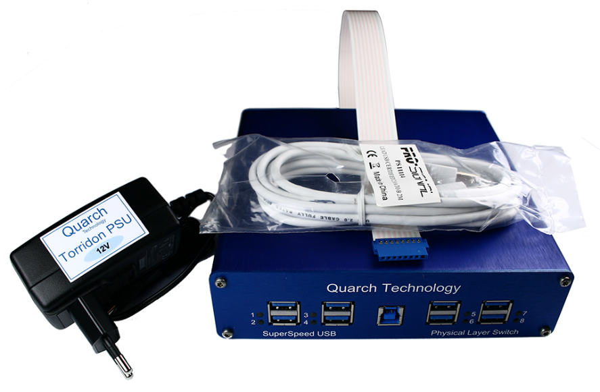

Change History
1.0 |  | Beta Release
1.2 |  | Changed object model, first full release
1.3.1 |  | Added QIS functions
1.3.2 |  | Fixed bug when locally running QIS
1.3.3 |  | Added additional QIS useful functions
1.3.4 |  | Improved QIS launch mechanism  Implemented QIS resampling
1.5.5 |  | Added FIO functions and various bug fixes

Contents
Change History 2
Introduction 4
Modules Supported 5
Requirements 6
Installation 6
Python 6
QuarchPy Package 6
Linux USB Permissions 8
Basic Setup 9
QuarchPy API Listings 11
Class descriptions 11
Helper functions 18
FIO specific functions 20
Customer support from Quarch 21
Access support from the Quarch website 21
Find discussion topics, support information and testing ideas. 21

Introduction
Quarch modules can be easily controlled using Python through multiple interface options:
- USB
- Serial
- REST
- Telnet
QuarchPy is a python package designed to provide an easy to use API which will work seamlessly over any of the communication options.
The package contains all prerequisites needed as a single PyPI project which can be installed from the python online repository or a downloaded local copy.
This makes it easy to install and keep up to date, while also providing you with full access to the source code if you want to make changes or additions.
The package also includes several additional sections
- QIS (Quarch Instrument Server)
This is a headless Java application which handles all the data and multi-thread intensive work needed to stream high-speed data from Quarch Power Modules.
While it is possible to control power modules with pure Python code, the efficiency is much poorer and streaming speeds will be limited.
QIS is automatically started when a ‘QIS’ type connection is requested.
- QPS (Quarch Power Studio)
This is a Java based application for control of the Quarch Power Modules. Also available for download from our site, a version is supplied here as QPS can be automated from Python and controlled via script.
If you request a QPS connection, the application will be automatically launched, and you can see the live power data while the automatic capture is running. This provides a great way to get an overview on the results while running a fully automated test.

Modules Supported
- All breaker/hot-swap modules
- All Power modules
- All Physical layer switch modules

Requirements
- Windows or Linux PC
- Python 2.x or Python 3.x
- Quarch USB driver (Windows only)

Installation

Python
If Python is not installed on your system, go to https://www.python.org/downloads/ and choose the relevant version for your system.
Under Windows it is sensible to ensure the Python installation directory and PythonXX\Scripts are included in the PATH environment variable. See HERE for instructions on how to do this.

QuarchPy Package
The Quarch Python package can be installed from the Python web repository (assuming you have internet access) or via the download from our site which contained this document.

Web Install
From the command line:
>pip install quarchpy
If this fails, your path to “pip” may not be set, you can instead run:
>python –m pip install quarchpy

Local Install
If you want to install from a downloaded .whl file, download the file from https://pypi.org/manage/project/quarchpy/releases/, navigate to the folder containing the quarchpy-x.y.z-py2.py3-none-any.whl file and run:
>pip install quarchpy-x.y.z-py2.py3-none-any.whl
If this fails, your path to ‘pip’ may not be set, you can instead run:
>python –m pip install quarchpy-x.y.z-py2.py3-none-any.whl
Upgrade
If you already have QuarchPy installed, you will get a failure message. If you want to upgrade to a new version, you need to add the ‘--upgrade’ command:
>pip install --upgrade quarchpy
The --upgrade command can similarly be used in any of the other examples, to load from a local install folder.

Linux USB Permissions
Linux systems require administrative rights to run python scripts for modules connected via USB. You can do that by running your script as root (sudo command) or changing the default USB permissions. This is done by creating a text file called Quarch-permissions-usb.rules
For ubuntu systems, you need to enter into that file:
SUBSYSTEM == “usb”, ATTRS{idVendor}==”16d0”, MODE=”0666”
SUBSYSTEM == “usb_device”, ATTRS{idVendor}==”16d0”, MODE=”0666”
For Centos systems, you need:
SUBSYSTEM == “usb”, ATTRS{idVendor}==”16d0”, GROUP=”users”, MODE=”0666”
SUBSYSTEM == “usb_device”, ATTRS{idVendor}==”16d0”, GROUP=”users”, MODE=”0666”
This file needs to be placed in /etc/udev/rules.d
Finally, the system either needs to be restarted or run the command:
>sudo udevadm control -reload
Then reconnect the USB device.

Basic Setup
We strongly recommend you download a relevant application note to demonstrate the use of the Python API, only the basics are shown here.
Below is a simple example to import and use a Quarch module.
# Imports QuarchPy package
from quarchpy import *
# Open a connection to a module on USB
myDevice = quarchDevice(“usb:QTL1999-01-002”)
For USB connections, you specify a full, or partial serial number, as found on the product label.
For LAN connections (ReST and Telnet) you can specify either an IP address, or NetBIOS name (if supported by your network). The default NetBIOS name for most modules is the serial number:
myDevice = quarchDevice (“telnet:192.168.1.55”)
Or
myDevice = quarchDevice (“telnet:QTL1079-03-137”)
For Serial connections, specify the COM port on windows
myDevice = quarchDevice (“SERIAL:COM4”)
Or the linux serial port ID
myDevice = quarchDevice (“SERIAL:ttyS0”) or you may need
myDevice = quarchDevice (“SERIAL:/dev/ttyS0”)

You can now send commands to the module. The full command list for each module can be found in its Technical Manual, which can be downloaded from www.quarch.com.
To send the simple ‘hello?’ command, use:
myDevice.sendCommand ("hello?")
This function will return the command response, so you can easily see the result with:
print (myDevice.SendCommand("hello?"))
Finally you must close the connection with
myDevice.closeConnection()

QuarchPy API Listings

Class descriptions
quarchDevice
Starts a connection and implements basic control over any Quarch device.
quarchDevice (ConString, [ConType = "PY"], [timeout = "5"])
argument string ConString
Specifies the device to connect to by COM port, IP address or USB ID
USB:QTL1177 or USB:QTL1177-02 or USB:QTL1177-02-012
Will connect to the first device found matching the string.
SERIAL:COM4 or SERIAL:ttys0
Linux only: ls /dev/serial/ lists serial connections in your system.
TELNET:192.168.1.102 or TELNET:QTL1079-02-004
You can use NetBIOS name if your networks supports it.
REST:192.168.1.102 or REST:QTL1079-02-004
You can use NetBIOS name if your networks supports it.
argument string ConType
Allows additional information on connection type for QIS and similar
QIS
Local instance of QIS
QIS:192.168.100.102:9722
QIS:ip:port
QPS
Local instance of QPS
PY
Python connection
argument string timeout
Specifies a timeout when searching for device
return object quarchDevice
sendCommand(command)
Sends a command to the device.
argument string command
Torridon command to send
return string
Answer from module.
openConnection()
Opens a connection with device.
closeConnection()
Closes the connection with device and any open communication ports.
qisInterface
Implements direct communication with QIS.
qisInterface([host=127.0.0.1], [port=9722] )
argument string host
Specify the remote host ip.
argument integer port
Specify the remote host port.
return object qisInterface
getDeviceList()
Returns a list of devices connected to the QIS interface object.
return list
Returns a list of devices connected to the QIS interface object.

quarchPPM
Extends quarchDevice to provide additional functions for power modules.
quarchPPM(quarchDevice)
argument quarchDevice object quarchDevice
Basic quarchDevice object to use as a power module.
startStream([fileName='streamData.txt'], [fileMaxMB=2000], [streamName ='Stream With No Name'], [streamAverage = None], [releaseOnData = False)]
argument string fileName
Base file name for the output files.
argument int fileMaxMB
Maximun size of a file before creating a new one (default = 2000).
argument string streamName
Name for stream file header (default = "Stream With no Name").
argument string streamAverage
Sets the averaging for the stream.
argument boolean releaseOnData
If True, only returns from startStream after th first row of data is returned form the module.
streamResampleMode (resampleRate)
Sets the resampling mode.
argument resampleRate
off, [x]ms or [x]us
stopStream()
Stops stream.

quarchQPS
Implements the interface with QPS.
quarchQPS (quarchDevice)
argument quarchDevice object quarchDevice
quarchDevice Object.
startStream (directory)
argument path directory
Declares where the data from the stream will be located.
return object quarchStream

quarchStream
Implements an interface with QPS stream.
quarchStream (quarchQPS)
argument quarchQPS object quarchQPS
quarchQPS object connected to QPS.
openConnection()
Re-open the connection if it has been closed.
closeConnection()
Closes the device connection and any open communication ports.
createChannel (channelName, channelGroup, baseUnits, usePrefix)
Creates a new channel in QPS.
argument string channelName
Name of channel that will be add to QPS.
argument string channelGroup
Name of channel group that the channel will be add to.
argument string baseUnits
Unit for the new channel.
argument boolean usePrefix
Wether the new channel will automatically use metric prefixes to represent numbers.
hideChannel (channelSpecifier)
Hides a channel within QPS.
argument string channelSpecifier
The channel name the user wants to hide.
hideAllDefaultChannels
Hides as default channels. Only user specified channels will be visible.
showChannel (channelSpecifier)
Show a specific channel in QPS.
argument string channelSpecifier
The channel name the user wants to show.
addAnnotation (annotationString, [annotationTime=0])
Adds an annotation at a specified point in graph.
Annotations will be used to create the statistics table.
argument string annotationString
Annotation string that will appear in QPS.
"text to show"
Will show this whole string on graph.
"<<text> text to show</text> <extraText> text to hide</extraText>>"
Add the option to hide part of the string. This can be accessed righ clicking in the annotation.
argument string annotationTime
Either UNIX time or as elapsed time since the start of the dataset.
1528370532877
Unix time.
e12D13:14:15.167
Specifies 12 days, 13 hours, 14 minutes, 15.167 seconds
addComment (commentString, [commentTime=0])
Adds a comment at a specified point in graph.
Comments will be hidden from the statistics table.
argument string commentString
Comment string that will appear in QPS.
"text to show"
Will show this whole string on graph.
"<<text> text to show</text> <extraText> text to hide</extraText>>"
Add the option to hide part of the string. This can be accessed righ clicking in the comment
argument string commentTime
Either UNIX time or as elapsed time since the start of the dataset.
1528370532877
Unix time.
e12D13:14:15.167
Specifies 12 days, 13 hours, 14 minutes, 15.167 seconds
addDataPoint (channelName, groupName, dataValue, [dataPointTime])
Adds a new data point to the specified channel for representation on graph.
argument string channelName
Name of channel that will be add to QPS.
argument string groupName
Name of channel group that the channel will be add to.
argument int driveTemp
Value of the data point.
argument string dataPointTime
1528370532877
Unix time.
e12D13:14:15.167
Specifies 12 days, 13 hours, 14 minutes, 15.167 seconds
stopStream()
Stops the current stream.
myChannels()
Returns the active channel.
return list
List of channels currently active in QPS.

Helper functions
QIS
isQisRunning ([host="localhost"], [port"9722"])
Returns wheter QIS is running or not.
argument string host
Specify the remote host ip.
argument integer port
Specify the remote host port.
return boolean
True if QIS is running or False if not.
startLocalQis ([QisPath=/path/inside/QuarchPy])
Start a copy of QIS.
argument path QisPath
Path to a custom QIS folder.
closeQis (host, port)
Closes QIS.
argument string host
Specify the remote host ip.
argument integer port
Specify the remote host port.

QPS
isQpsRunning ([host="localhost"], [port"9722"])
Returns wheter QPS is running or not.
argument string host
Specify the remote host ip.
argument integer port
Specify the remote host port.
return boolean
True if QPS is running or False if not.
startLocalQps ([keepQisRunning=False], args=[])
Starts a new instance of QPS.
argument path QisPath
Path to a custom QPS folder.
argument boolean keepQisRunning
Will keep QIS running after the execution of the script.
closeQps (host, port)
argument string host
Specify the remote host ip.
argument integer port
Specify the remote host port.

FIO specific functions
FIO
runFIO (myStream, mode, fioCallbacks, user_data, [arguments], [file_name])
Runs FIO.
argument qpsStream object myStream
Your QPS stream where you want to send the data points to.
argument string mode
Selects the execution mode.
file
QuarchPy with parse the paraemters from the variable "fioFile".
arg
QuarchPy will parse the parameters from the variable "arguments".
cli
FIO will run the same way it would in a shell.
argument dictionary fioCallbacks
A dictionary containing all the callbacks for FIO.
argument list user_data
List of arguments to return from FIO.
argument dictionary arguments
List of arguments to send to FIO.
argument string file_name
File with FIO configuration.
GetQpsModuleSelection (QpsConnection)
Prompts the user to choose a module.
argument qpsStream object QpsConnection
Your QPS connection.

Customer support from Quarch
There are multiple ways to access the support you need. You can contact us directly or access an extensive range of valuable support materials from http://quarch.com/support.
- Contact us direct
- Get going quickly and easily, with help direct from the engineers:
- Call +44 1343 508 140 or email support@quarch.com during UK office hours.
- Our international partners are well trained in the use of our products and can deal with many basic technical queries from within your time zone, if you prefer. Check http://quarch.com/resellers for the contact details of your regional supplier.

Access support from the Quarch website
You can download up-to-date software and drivers, technical manuals, datasheets and more from our website. To help you get started quickly we provide additional documents, such as examples in Perl, Python and C# and Telnet and Serial instructions.
- Key places to visit on the Quarch website
- Register your Quarch product to confirm your international warranty: http://quarch.com/product-registration
- Download a wide range of documentation, free applications and drivers to help you make the best possible use of your Quarch tools: http://quarch.com/content/downloads
- Access the Quarch support forum (http://quarch.com/forum):

Find discussion topics, support information and testing ideas.
Browse existing topics or login to your user account to ask for information and advice.
Sign up for Quarch Technical Updates to get the most out of your Quarch products. Updates are published approximately once a quarter and include news about the latest features, tools, application notes and software updates. See http://quarch.com/content/sign-quarch-technical-updates.

